|  |
| --- |
| José Coronil Álvarez (joscoralv@alum.us.es)  Miguel García Vizcaíno (miggarviz@alum.us.es)  Javier Ignacio Milá de la Roca Dos Santos (javmildos@alum.us.es)  Emilio Manuel Vázquez Cruz ([emivazcru@alum.us.es](mailto:emivazcru@alum.us.es))  Group C1.028  3-13-2025 |

|  |
| --- |
| Acme AirNav Solutions, Inc. |
| **Analysis Report – Student #2** |
| https://github.com/Emilio-115/DP2-Acme-ANS |



**Contents**

Executive Summary 2

Revision Table 2

Introduction 3

Analysis Records 3

Conclusions 3

Bibliography 3

# Executive Summary

Problems were found with the passenger and booking relation due to it was many to many, thanks a forum thread and theory lessons the solution was easy. Furthermore, some questions about the properties range and restrictions appeared but with the help of the forum threads, follow-up and theory lessons they were clarified.

# Revision Table

|  |  |  |
| --- | --- | --- |
| Revision number | Date | Description |
| 1 | 3-13-2025 | Initial version |

# Introduction

This document is a report about the analysis needed to understand the student 2 individual mandatory information requirements. The report explains the found problems, the process and tools that were used to find a solution and what was finally decided to implement.

# Analysis Records

In this second delivery the supplementary requirements were clear enough and were finished without problem, the problems were related to the following mandatory requirements:

*Information requirement 5*:

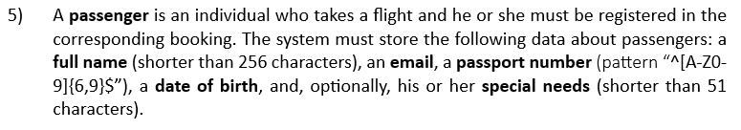

The passengers have a relation many to many, however, this type of relations is no recommend so it was needed other implementation, thanks to the theory and the thread of the forum below it was correctly implemented. The intermediate class BookingRecord was created to associate a passenger to a booking, the class has a many to one relation to booking and a many to one relation to passenger.

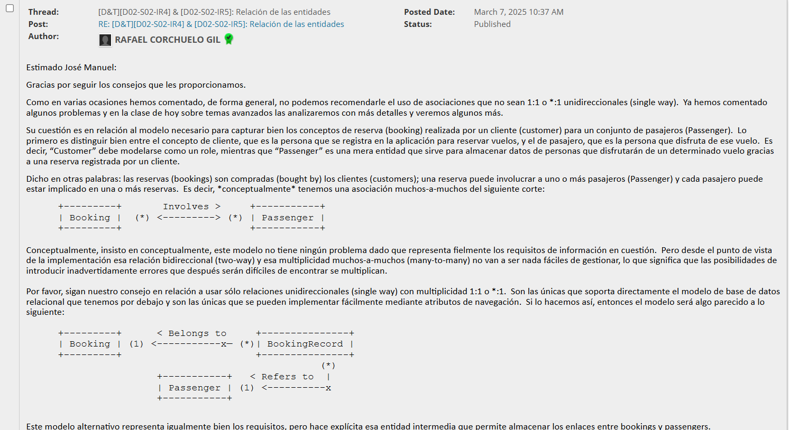

Some of the information requirements properties, such as booking last nibble property or price, needed an analysis to ensure the range and type of various properties, some of the doubts were solved in the follow-up lessons and other were clarified in the forum thread below. Finally, the ranges where successfully added, the last nibble property was implemented with a regular expression, the maximum and minimum of money is the limit established by the framework and some small restrictions were reviewed to fulfill the requirements.

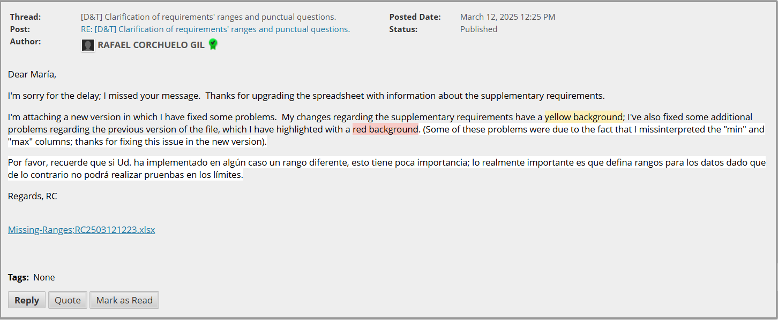

Most of these decisions were validated in the 10 March 2025 follow-up class.

# Conclusions

In conclusion, the first delivery was successful, with the done supplementary requirements being clear and manageable. However, the mandatory requirements gave some problems with the relations and some properties ranges and restrictions. The forum threads and follow-up sessions were very helpful to accomplish with the requirements.

# Bibliography

Intentionally blank.